Year 11 Mathematics Specialist
2018 Revision Assignment 2
Take Home

Instructions: to be completed at home, Calculators are permitted.
Time Allocation: 2 weeks (holiday), due ___/___/2018 Total Marks: 38 marks

- (6 marks: 3,3)
Let the complex numbers $u=2+ki$ and $v=-5+12i$, where k is a real number.
Determine all possible values of k if:
- ${\left[Im\left(u\right)\right]}^{2}=Im(v)$

- $\frac{6u}{v}=-i$

- (6 marks: 1, 1, 2, 2)
A class has 50 students.
- How many students need to be chosen at random to ensure that there are:
- Two students who are born on the same day of the week?

- Five students who are born on the same day of the week

- There are at least x students who are born on the same day of the week.
Find x, justify your answer

- There must be at least one day of the week which the birth day of no more than y students. Find y, justify your answer.

- (3 marks)
Given that |a|= 30 and |b|=15, find with reasons the maximum value and minimum value of a.b.

- (4 marks)
ABCD is a quadrilateral.
<DAB + <DCB = 180
<ADC + <ABC =180
Prove that there is a circle that passes through A, B, C and D.
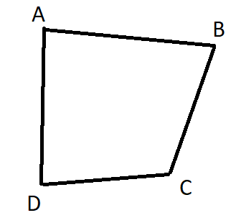

- (9 marks: 3 each)
- Prove that $\sqrt{1-\cos{x}}=\sqrt{2}\sin{\frac{x}{2}}$

- Prove that $\frac{\sin{x}}{1+\cos{x}}=\tan{\frac{x}{2}}$

- Prove that $\tan^{2}{\frac{3x}{2}}=\frac{1-\cos{3x}}{1+\cos{3x}}$

- (6 marks: 3,3)
A trigonometric function has the equation $y=-4\sin\left(2x+30\right), for 0≤x≤360$. Use an algebraic method to find:
- The maximum value for y and the corresponding value(s) for x.

- The minimum value for y and the corresponding value(s) for x.

- (4 marks)
Let X be an n×1 matric, A be a n×n matrix and ƛ be a real non-zero constant.
Given that $A X=ƛX$, prove that $\left|A-ƛI\right|=0$

End of Test

